

NATIONAL UNIVERSITY OF TECHNOLOGY
(Department of Computer Science)
CS161– Database Systems
Instructor: Noushin Saba
Name: Bisma Fatima
Roll no: f24605036

LAB TASK 03

In Lab Tasks
Task 1
For the given database orders, create a Form for Order Details incorporating a calculated field to compute the Extended Price based on quantity and unit price.
Extended price = [Quantity] * [UnitPrice]
STEPS
Step 1: Create a new form
- Go to the "Create" tab in the ribbon
- Click on the "Form Design" button
- Select the "Order Details" table as the record source
Step 2: Add fields to the form
- Drag and drop the following fields from the "Order Details" table to the form design:
- OrderID
- ProductID
- Quantity
- UnitPrice
Step 3: Create a calculated field for Extended Price
- Right-click on the form design and select "Insert" > "Text Box"
- Drag the text box to the desired location on the form
- Right-click on the text box and select "Properties"
- In the "Properties" window, click on the "Data" tab
- In the "Control Source" field, enter the following formula:

=[Quantity] * [UnitPrice]
Step 4: Format the calculated field
- In the "Properties" window, click on the "Format" tab
- Select the desired format for the Extended Price field (e.g. currency)
Step 5: Save and view the form
- Save the form by clicking on the "Save" button
- Switch to "Form View" by clicking on the "View" button
- Test the form by entering data into the Quantity and UnitPrice fields.

DESIGN VIEW
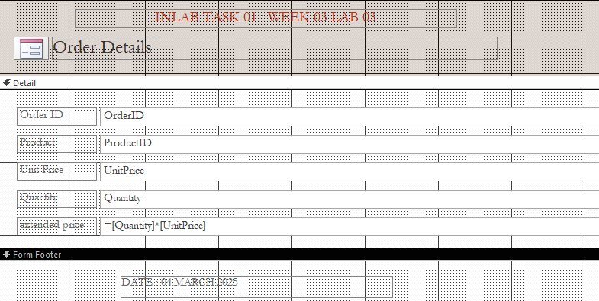

FORM VIEW
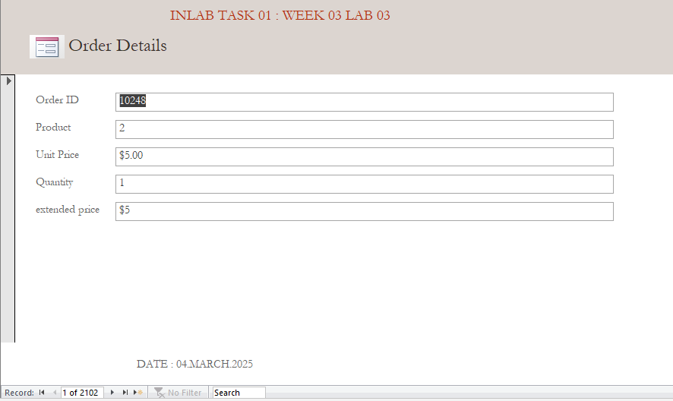
Formatted form
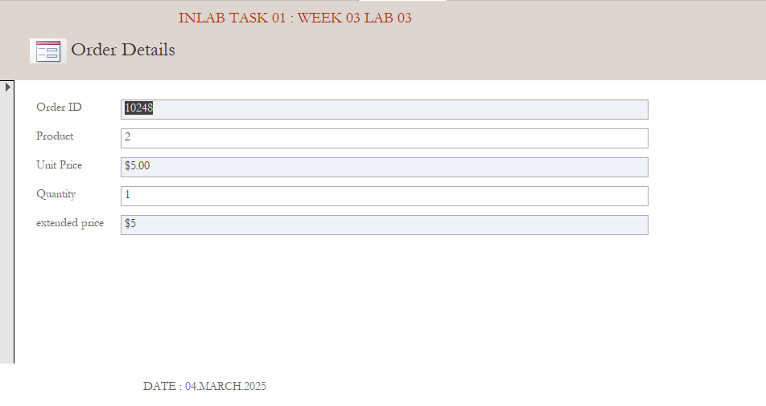
Task 2
Create a Report for Task 1.
Steps
1. Go to the Create Tab: Click on the "Create" tab in the ribbon.
2. Click on Report: Click on the "Report" button in the "Reports" group.
3. Select Record Source: Choose the table or query that you want to use as the record source for the report.
4. Save the Report: Save the report with a descriptive name.

Design view
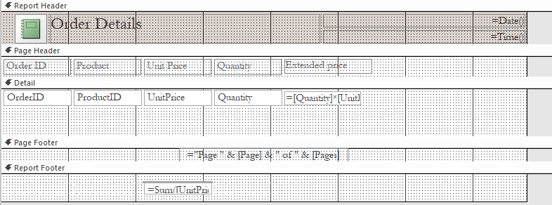

REPORT VIEW
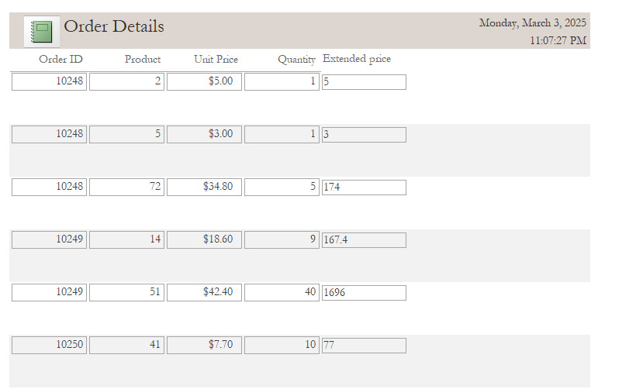

Post Lab Tasks

Task 1
Modify your Order Details Form to include a drop-down list (combo box) for selecting products instead of entering product names manually. Add a submit button to save records easily.
STEPS
1. Create a Products table: Store product information, including Product ID, Product Name, and Unit Price.
2. Add a combo box to the form: Select "Combo Box" from the toolbox and add it to the form.
3. Set the combo box properties: Set the "Row Source" property to the Products table, and the "Bound Column" property to the Product ID field.
4. Add a submit button: Select "Button" from the toolbox and add it to the form.
5. Set the submit button properties: Set the "On Click" property to a macro or VBA code that saves the record.
6. Modify the form's VBA code: Update the code to retrieve the selected product's Unit Price and calculate the total.
DESIGN VIEW
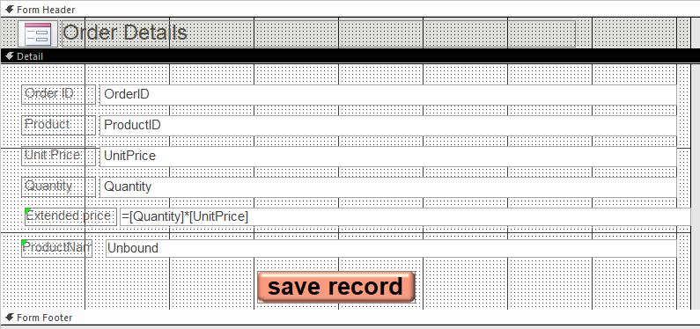

FORM VIEW
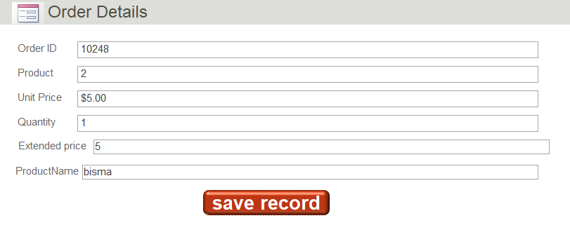

Task 2
Add a Report Footer that displays the total extended price (sum of all extended prices).
DESIGN VIEW
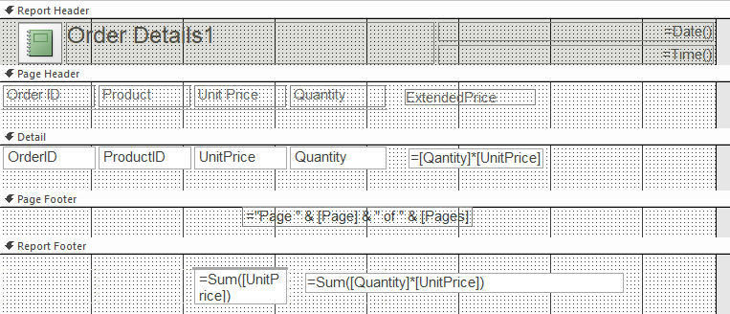
REPORT VIEW
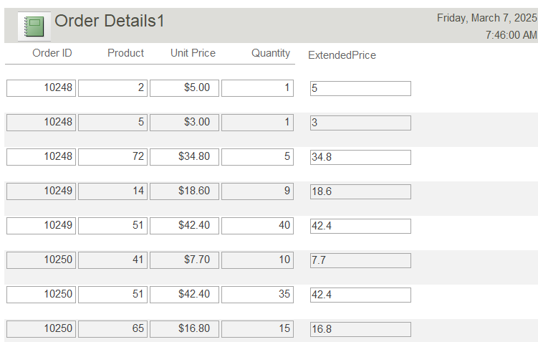



Lifelong Learning Component
How can the principles of form design and report generation in MS Access be applied to real-world scenarios beyond business database management? Provide an example from a different industry, such as healthcare or education, and explain how continuous learning in database management is essential for improving data entry efficiency and decision-making.
ANSWER:
The principles of form design and report generation in MS Access can be applied to various real-world scenarios beyond business database management. Here's an example from the healthcare industry:
Example: Patient Care Management in Healthcare
In a hospital setting, nurses and doctors need to manage patient care effectively. A well-designed database can help streamline patient data management, improve care coordination, and enhance decision-making.
Form Design:
A customized form in MS Access can be designed to capture patient information, such as:
- Patient demographics
- Medical history
- Medications
- Lab results
- Treatment plans

The form can be designed with various controls, such as:
- Text boxes for data entry
- Drop-down lists for selecting medications or treatment options
- Checkboxes for tracking patient conditions or allergies
- Buttons for navigating to different sections of the form
Report Generation:
Reports can be generated to provide insights into patient care, such as:
- Patient summaries
- Medication lists
- Lab result trends
- Treatment plan effectiveness
Reports can be designed to display data in a clear and concise manner, using various formatting options, such as:
- Tables and charts
- Conditional formatting
- Grouping and sorting
Continuous Learning:
Continuous learning in database management is essential for improving data entry efficiency and decision-making in various industries, including healthcare. By staying up-to-date with the latest database management techniques and best practices, healthcare professionals can:
- Improve data accuracy and completeness
- Enhance patient care coordination
- Optimize treatment plans
- Reduce medical errors

In conclusion, the principles of form design and report generation in MS Access can be applied to various real-world scenarios, including patient care management in healthcare. Continuous learning in database management is crucial for improving data entry efficiency and decision-making, ultimately leading to better patient outcomes.

